Supplementary appendix

**Pain relieving interventions for retinopathy of prematurity: Systematic review and network meta-analysis**

Disher, T., Cameron, C., Mitra, S., Cathcart, K., Campbell-Yeo, M.

Table of Contents

Appendix 1 MEDLINE Search Strategy 3

Ovid MEDLINE(R) Epub Ahead of Print, In-Process & Other Non-Indexed Citations, Ovid MEDLINE(R) Daily and Ovid MEDLINE(R) 3

Appendix 2 Supplementary Tables 4

Supplementary table 2.1. Intervention lumping and abbreviations 4

Supplementary table 2.2. Characteristics of studies 6

Supplementary table 2.3. Reasons for exclusion from quantitative synthesis by outcome 8

Supplementary table 2.4. Node splitting results including Boyle 9

Supplementary table 2.5. Node splitting results excluding Boyle and imputed means (Best fitting model) 10

Supplementary table 2.6. Selection of adverse events for inclusion in meta-analysis 11

Supplementary table 2.7. Model fit statistics 12

Appendix 3. Supplementary Figures 13

Supplementary figure 3.1. PRISMA flow diagram 13

Supplementary figure 3.2. Risk of Bias of included studies 14

Supplementary figure 3.3. Pain reactivity all pairwise comparisons with direct and indirect evidence including all trials. 15

Supplementary figure 3.4. Pain reactivity all pairwise comparisons with direct and indirect evidence excluding Boyle and studies with imputed means 16

Supplementary figure 3.5. PIPP reactivity sensitivity analysis based on SUCRA 17

Supplementary figure 3.6. PIPP regulation sensitivity analyses based on SUCRA. 18

Supplementary figure 3.7 Pain regulation league table of NMA estimates. 19

Supplementary figure 3.8. Pain regulation all pairwise comparisons with direct and indirect evidence. 20

Supplementary figure 3.9.Heart rate regulation league table of NMA estimates. 21

Supplementary figure 3.10. SpO2 reactivity league table of NMA estimates. 22

Supplementary figure 3.11. Cry time league table of NMA estimates 23

Supplementary figure 12. Adverse event reactivity league table of NMA estimates. 24

Supplementary figure 13. Adverse event regulation league table of NMA estimates. 25

Appendix 4. PROSPERO protocol and list of deviations 26

Supplementary table 4.1. Deviations from protocol 32

# Appendix 1 MEDLINE Search Strategy

## Ovid MEDLINE(R) Epub Ahead of Print, In-Process & Other Non-Indexed Citations, Ovid MEDLINE(R) Daily and Ovid MEDLINE(R)

1. Retinopathy of Prematurity/

2. exp Ophthalmoscopy/

3. retinopath*.tw.

4. retrolental fibroplasia?.tw.

5. ophthalmoscop*.tw.

6. (scleral adj (depress* or indent*)).tw.

7. 1 or 2 or 3 or 4 or 5 or 6

8. exp Infant, Newborn/

9. ((prematur* or pre-matur* or preterm* or pre-term*) adj2 (infant* or newborn? or baby or babies or neonat* or neo-nat* or child*)).tw.

10. (premie? or preemie?).tw.

11. (low adj2 (birthweight? or birth weight?)).tw.

12. (small adj2 gestation* age).tw.

13. 8 or 9 or 10 or 11 or 12

14. exp Pain/

15. Pain Management/

16. Pain Measurement/

17. exp Analgesia/

18. exp Analgesics/

19. Anesthetics, Local/

20. pain*.tw.

21. analgesia.tw.

22. analgesic?.tw.

23. (local* adj2 anesthetic?).tw.

24. comfort*.tw.

25. discomfort*.tw.

26. stress*.tw.

27. sooth*.tw.

28. (pacify* or pacifie*).tw.

29. 14 or 15 or 16 or 17 or 18 or 19 or 20 or 21 or 22 or 23 or 24 or 25 or 26 or 27 or 28

30. 7 and 13 and 29

# Appendix 2 Supplementary Tables

## **Supplementary table 2.1. Intervention lumping and abbreviations**

|  |  |  |  |
| --- | --- | --- | --- |
| **Intervention** | **Group** | **Rationale/Description** | **Abbreviation** |
| *No anesthetic eye drops* |  |  |  |
| Non-nutritive sucking | Physical | Mechanism of action through distraction | NNS |
| Placebo | Placebo | - | No treatment |
| Sweet taste alone | Sweet taste alone | Sucrose and glucose combined, similar mechanism | Sweet taste |
| Repeated sweet taste |  |  | Sweet taste + rep |
| Sweet taste with singing | Sweet taste + singing | Unique intervention | Sweet taste + singing |
| *Anesthetic eye drops* | | |  |
| Topical anesthetic drops alone | Eye drops alone | - | TA |
| No speculum | Eye drops + no speculum | Speculum thought to be major painful component of intervention | TA + no_spec |
| Sweet taste | Eye drops + sweet | Sucrose + glucose combined, similar mechanism | TA + Sweet taste |
| Wide-field digital retina imaging (WFDRI) | Eye drops + WFDRI | Camera does not require scleral depression and can be done more rapidly | TA + WFDRI |
| Feeding one hour prior | Eye drops + diet one hour | Infants fed one hour before procedure | TA + 1hr feed |
| Feeding two hours prior | Eye drops + diet two hours | Infants fed two hours before procedure | TA + 2hr feed |
| Non-nutritive sucking | Eye drops + physical | Mechanism of action through distraction | TA + NNS |
| Sweet + nitrous oxide | Eye drops + sweet + N2O | Sweet taste combined with additional pharmacological intervention | TA + Sweet taste + NO |
| Acetaminophen 30 minutes prior to procedure | Eye drops + acetaminophen 30 minutes | Time of onset of acetaminophen in neonates approximately 60 minutes | TA + Acetaminophen 30m |
| Acetaminophen 60 minutes prior to procedure | Eye drops + acetaminophen 60 minutes | TA + Acetaminophen 60m |
| Sensorial saturation | Eye drops + sweet multisensory | Combines sweet taste, non-nutritive sucking, swaddling, touch, voice, and familiar odour | TA + Sweet taste multisensory |
| NIDCAP | Eye drops + sweet multisensory | Combines sweet taste, non-nutritive sucking, swaddling, touch, and voice | TA + Sweet taste multisensory |
| Cup-fed expressed breast milk | Eye drops + ebm multisensory | Cup feeding provides olfactory and gustatory stimulation | TA + EBM multisensory |
| Expressed breast milk + non-nutritive sucking | Eye drops + ebm multisensory | Combines gustatory and physical stimulation | TA + EBM multisensory |

## Supplementary table 2.2. Characteristics of studies

|  |  |  |  |  |  |  |  |
| --- | --- | --- | --- | --- | --- | --- | --- |
| Author and year | Design | Method | Speculum | Scleral depression | PMA (weeks,  mean) | BW (grams,  mean) | Treatments |
| Boyle 2006 | Parallel | BIO | yes | yes | 34.9 | 1132.8 | TA vs TA + Sweet taste vs NNS + TA vs Sweet taste multisensory + TA |
| Cogen 2011 | Parallel | BIO | yes | yes | 34 | 924 | No treatment vs TA |
| Costa 2013 | Parallel | BIO | yes | yes | 35.2 | 1260.9 | TA vs TA + Sweet taste |
| Dhaliwal 2010 | Crossover | WFDRI | yes | no | 34.1 | 1208 | TA vs WFDRI + TA |
| Dilli 2014 | Parallel | BIO | yes | unclear | 35.4 | 1304 | TA + NNS vs Sweet taste multisensory + TA |
| Gal 2005 | Crossover | BIO | yes | yes | 33.3 | NA | TA vs TA + Sweet taste |
| Grabska 2005 | Parallel | BIO | yes | yes | 35.3 | 1880 | TA + NNS vs Sweet taste multisensory + TA |
| Kabatas 2016 | Parallel | BIO | yes | unclear | 32.4 | 1130.3 | TA vs Acetaminophen + TA |
| Kleberg 2008 | Crossover | BIO or WFDRI | yes | yes in London | NA | NA | TA vs Sweet taste multisensory + TA |
| Mandel 2012 | Parallel | BIO | yes | yes | 35.2 | 1025.4 | TA + Sweet taste vs NO + Sweet taste + TA |
| Marsh 2005 | Crossover | BIO | yes | yes | 33 | NA | No treatment vs TA |
| Mehta 2010 | Crossover | BIO | yes | yes | NA | NA | NNS vs NNS + TA |
| Mitchell 2004 | Parallel | BIO | yes | yes | 35.2 | 976 | TA + NNS vs Sweet taste multisensory + TA |
| Nesargi 2015 | Parallel | BIO | yes | yes | 34.3 | 1167 | TA vs Sweet taste |
| Olsson 2011 | Parallel | BIO | no | unclear | NA | 1126.5 | TA vs TA + Sweet taste |
| O'sullivan 2010 | Parallel | BIO | yes | yes | 33.1 | 1140 | TA + NNS vs Sweet taste multisensory + TA |
| Rosali 2015 | Parallel | BIO | yes | yes | 34.6 | 1356 | TA vs ebm + TA |
| Rush 2005 | Parallel | BIO | yes | unclear | NA | 1185.3 | TA vs Sweet taste multisensory + TA |
| Saunders 1993 | Parallel | BIO | yes | yes | 36 | 1093 | No treatment vs TA |
| Strube 2010 | Parallel | BIO | yes | yes | 35.8 | 1091.7 | 1hr + feed vs 2hr + feed |
| Manjunatha 2009 | Parallel | BIO | yes | yes | NA | NA | TA vs morphine + TA vs Acetaminophen + TA |
| Seifi 2013 | Parallel | BIO | yes | yes | NA | 987.1 | TA vs TA + Sweet taste vs Acetaminophen + TA |
| Zeraati 2016 | Parallel | unclear | unclear | unclear | 35.5 | 1370.8 | TA vs sensorial + saturation |
| SenerTaplak 2017 | Parallel | BIO | yes | yes | NA | NA | TA + NNS vs EBM multisensory + TA vs Sweet taste multisensory + TA |
| Benzer 2015 | Parallel | unclear | unclear | unclear | NA | NA | No treatment vs Sweet taste + rep vs Sweet taste + singing |
| Ilarslan 2012 | Parallel | unclear | yes | unclear | NA | NA | TA + NNS vs NNS + TA + Sweet taste |
| Mehta 2005 | Crossover | bio and wfdri | yes | no | NA | NA | TA + Speculum vs TA – Speculum vs TA + WFDRI |
| Ucar 2014 | Parallel | unclear | unclear | unclear | 34.2 | 1280 | TA + NNS vs TA + Sweet taste vs Sweet taste multisensory + TA |
| Xin 2016 | Parallel | unclear | unclear | unclear | NA | NA | TA vs TA + Sweet taste |
| BIO = Binocular indirect ophthalmoscopy  WFDRI = Wide-field Digital Retina Imaging | | | | | | | |

## Supplementary table 2.3. Reasons for exclusion from quantitative synthesis by outcome

|  |  |  |  |
| --- | --- | --- | --- |
| Author and year | Sample size | Treatments | Reason |
| **Pain Reactivity** | | | |
| Olsson 2011 | 29 | TA vs TA + Sweet taste | Does not use speculum |
| Ucar 2014 | 81 | TA + NNS vs TA + Sweet taste vs Sweet taste multisensory + TA | No variance info |
| Kabatas 2016 | 114 | TA vs TA + Acetaminophen 60min | Imputed mean |
| Kleberg 2008 | 68 | TA vs TA + Sweet taste multisensory | Imputed mean |
| O’sullivan 2010 | 40 | TA + Sweet taste multisensory vs TA + NNS | Imputed mean |
| **Heart rate reactivity** | | | |
| Olsson 2011 | 29 | TA vs TA + Sweet taste | Does not use speculum |
| Mehta 2005 | 45 | TA vs TA + No speculum vs TA + WFDRI | No variance info |
| Dhaliwal 2010 | 152 | TA + WFDRI vs TA | HR max not an outcome of interest |
| **Heart rate recovery** | | | |
| Mehta 2005 | 45 | TA vs TA + No speculum vs TA + WFDRI | No variance info |
| **Oxygen saturation reactivity** | | | |
| Dhaliwhal 2010 | 152 | TA + WFDRI vs TA | Min 02 not an outcome of interest |
| Dilli 2014 | 64 | TA + Sweet taste multisensory vs TA + NNS | Analyzed with adverse events |
| Gal 2005 | 46 | TA + Sweet taste vs TA | Analyzed with adverse events |
| Marsh 2005 | 44 | TA vs placebo | not an outcome of interest |
| Mehta 2005 | 45 | TA vs TA + No speculum vs TA + WFDRI | No variance info |
| Olsson 2011 | 29 | TA vs TA + Sweet taste | Does not use speculum |
| **Oxygen Saturation regulation** | | | |
| Gal 2005 | 46 | TA + Sweet taste vs TA | Analyzed with adverse events |
| Marsh 2005 | 44 | TA vs placebo | not an outcome of interest |
| Mehta 2005 | 45 | TA vs TA + No speculum vs TA + WFDRI | No variance info |
| Mandel 2012 | 40 | TA_N2O_Sweet taste vs TA + Sweet taste | Analyzed with adverse events |
| **Cry time** |  |  |  |
| Olsson 2011 | 29 | TA vs TA + Sweet taste | Does not use speculum |
| Mehta 2005 | 45 | TA vs TA + No speculum vs TA + WFDRI | Outcome was presence/absence |
| Strube 2010 | 57 | TA_diet_1hr vs TA_diet_2hr | Diet is not in connected network |
| Saunders 1993 | 42 | Placebo vs TA | Outcome was “cry factor” |
| **Adverse events reactivity** | | | |
| Dilli 2014 | 64 | TA + Sweet taste multisensory vs TA + NNS | Not connected to network |
| O’sullivan 2010 | 40 | TA + Sweet taste multisensory vs TA + NNS | Not connected to network |
| **Adverse events regulation** | | | |
| Mandel 2012 | 40 | TA_N2O_Sweet taste vs TA + Sweet taste | Not expressed in counts |

## Supplementary table 2.4. Node splitting results including Boyle

|  |  |
| --- | --- |
| Comparison | CrI |
| **TA vs EBM multisensory + TA** | |
| Direct | -2.6 (-5.9, 0.64) |
| Indirect | -2.3 (-5.8, 1.2) |
| Network | -2.5 (-4.7, -0.23) |
| P-value | 0.90 |
| **TA vs NNS + TA** | |
| Direct | -3.0 (-6.5, 0.49) |
| Indirect | -1.6 (-3.6, 0.53) |
| Network | -1.9 (-3.8, -0.096) |
| P-value | 0.47 |
| **TA vs Sweet multisensory + TA** | |
| Direct | -2.7 (-4.5, -0.69) |
| Indirect | -5.8 (-8.6, -2.9) |
| Network | -3.5 (-5.1, -1.8) |
| P-value | 0.07 |
| **NNS + TA vs Sweet taste + TA** | |
| Direct | 2.0 (-0.78, 4.8) |
| Indirect | -2.4 (-4.8, -0.023) |
| Network | -0.76 (-2.9, 1.5) |
| P-value | 0.02 |
| **Sweet taste + TA vs Sweet taste multisensory + TA** | |
| Direct | -2.2 (-5.2, 0.78) |
| Indirect | 0.18 (-2.1, 2.5) |
| Network | -0.84 (-2.9, 1.2) |
| P-value | 0.18 |
| Node-splitting consists of dividing evidence for a treatment comparison into direct and indirect evidence by fitting separate models. P-values less than 0.05 were considered as statistically significant evidence of inconsistency. | |

## Supplementary table 2.5. Node splitting results excluding Boyle and imputed means (Best fitting model)

|  |  |
| --- | --- |
| Comparison | CrI |
| **TA vs EBM multisensory + TA** | |
| Direct | -2.6 (-5.7, 0.53) |
| Indirect | -2.4 (-6.6, 1.8) |
| Network | -2.5 (-4.8, -0.27) |
| P-value | 0.92 |
| **TA vs NNS + TA** | |
| Direct | NA |
| Indirect | NA |
| Network | NA |
| P-value | NA |
| **TA vs Sweet multisensory + TA** | |
| Direct | -3.6 (-6.7, -0.50) |
| Indirect | -3.8 (-8.2, 0.56) |
| Network | -3.7 (-5.9, -1.4) |
| P-value | 0.92 |
| **EBM multisensory + TA vs NNS + TA** | |
| Direct | -0.17 (-3.1, 2.7) |
| Indirect | 1.2 (-3.3, 5.5) |
| Network | 0.60 (-1.7, 2.8) |
| P-value | 0.51 |
| **EBM multisensory + TA vs Sweet taste multisensory + TA** | |
| Direct | -0.48 (-3.6, 2.6) |
| Indirect | -1.0 (-5.1, 3.1) |
| Network | -1.2 (-3.3, 1.0) |
| P-value | 0.80 |
| Node-splitting consists of dividing evidence for a treatment comparison into direct and indirect evidence by fitting separate models. P-values less than 0.05 were considered as statistically significant evidence of inconsistency. | |

## Supplementary table 2.6. Selection of adverse events for inclusion in meta-analysis

|  |  |
| --- | --- |
| Study and Outcomes | Outcome included in meta-analysis |
| **Reactivity** | |
| **Dilli 2014** |  |
| O2 desaturation < 85% | Bradycardia < 100bpm |
| Bradycardia < 100bpm |  |
| Tachycardia > 180bpm |  |
| **Gal 2005** |  |
| O2 desaturation > 10% | O2 desaturation > 10% |
| **Kabatas 2016** |  |
| Bradycardia or desaturation | Bradycardia or desaturation |
| Tachycardia > 180bpm |  |
| **Marsh 2005** | |
| O2 desaturation > 10% | O2 desaturation > 10% |
| **O’Sullivan** |  |
| Bradycardia < 100bpm | Bradycardia < 100bpm |
| O2 desaturation < 80% |  |
| **Recovery** | |
| **Gal 2005** |  |
| 02 desaturation > 10% | 02 desaturation > 10% |
| **Mandel 2012** |  |
| 02 < 88% in 24h | 02 < 88% in 24h |
| Apnea in 24h |  |
| **Marsh 2005** |  |
| 02 desaturation > 10% | 02 desaturation > 10% |
| 02 = Oxygen | |

## Supplementary table 2.7. Model fit statistics

|  |  |  |  |  |
| --- | --- | --- | --- | --- |
| Outcome and analysis | Model type | Ratio of posterior deviance to unconstrained data points | Between-study standard deviation | Beta coefficient  (95% Credible Interval) |
| **PIPP Reactivity** |  |  |  |  |
| Primary analysis | Random effect | 1.03 | 1.32 | NA |
| Remove Boyle | Random effect | 1.03 | 1.15 | NA |
| Post-menstrual age meta-regression | Random effect | 1.03 | 0.78 | NA |
| Risk of Bias meta-regression | Random effect | 1.04 | 1.21 | -2.8 (-6.7 to 1.3) |
| Remove posters | Random effect | 1.03 | 1.21 | -0.5 (-3 to 1.9) |
| Remove imputed mean | Random effect | 1.01 | 1.09 | NA |
| **PIPP Regulation** | Random effect |  |  |  |
| Primary analysis | Random effect | 0.99 | 2.37 | NA |
| Post-menstrual age meta-regression | Random effect | 0.96 | 1.54 | -4.4 (-11.3 to 3.2) |
| Risk of Bias meta-regression | Random effect | 0.99 | 2.51 | -0.8 (-6.2 to 4.3) |
| Timepoint meta-regression | Random effect | 1.00 | 2.28 | 2.0 (-3.9 to 7.3) |
| **Heart rate regulation** |  |  |  |  |
| Primary analysis | Fixed effect | 1.00 | NA | NA |
| **Oxygen saturation reactivity** |  |  |  |  |
| Primary analysis | Fixed effect | 1.00 | NA | NA |
| **Cry time** |  |  |  |  |
| Primary analysis | Fixed effect | 1.67 | NA | NA |
| **Adverse events reactivity** |  |  |  |  |
| Primary analysis | Fixed effect | 1.04 | NA | NA |
| **Adverse events regulation** |  |  |  |  |
| Primary analysis | Fixed effect | 1.06 | NA | NA |

# Appendix 3. Supplementary Figures

## Supplementary figure 3.1. PRISMA flow diagram

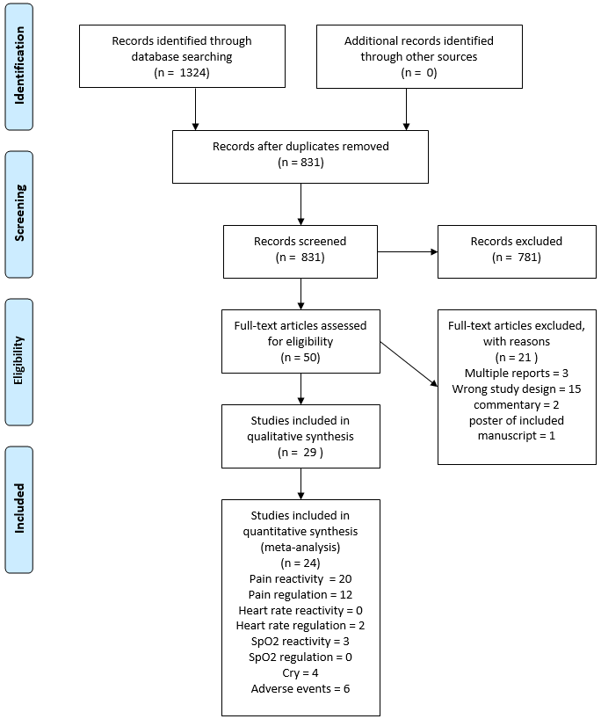

## Supplementary figure 3.2. Risk of Bias of included studies

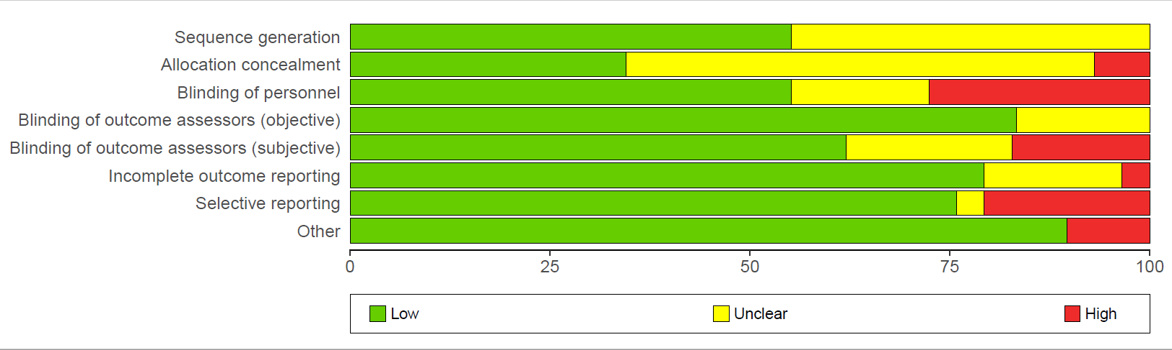

## Supplementary figure 3.3. Pain reactivity all pairwise comparisons with direct and indirect evidence including all trials.

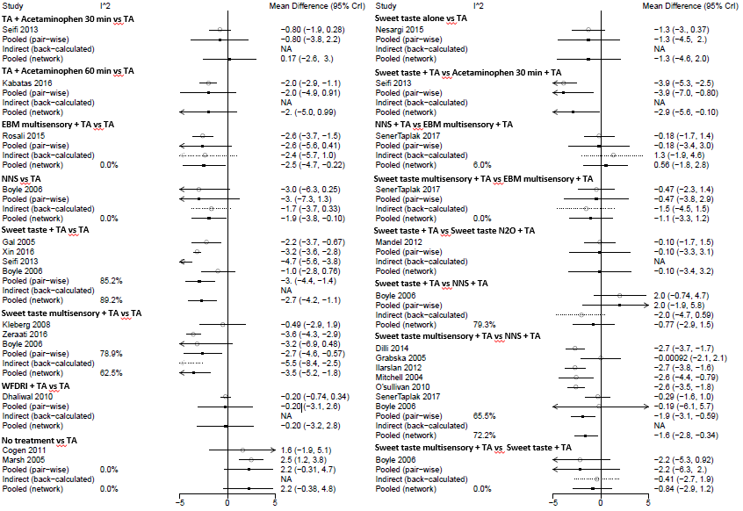

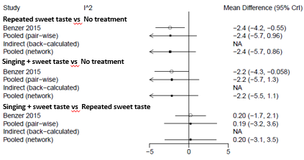

Supplementary figure 3.4. Pain reactivity all pairwise comparisons with direct and indirect evidence excluding Boyle and studies with imputed means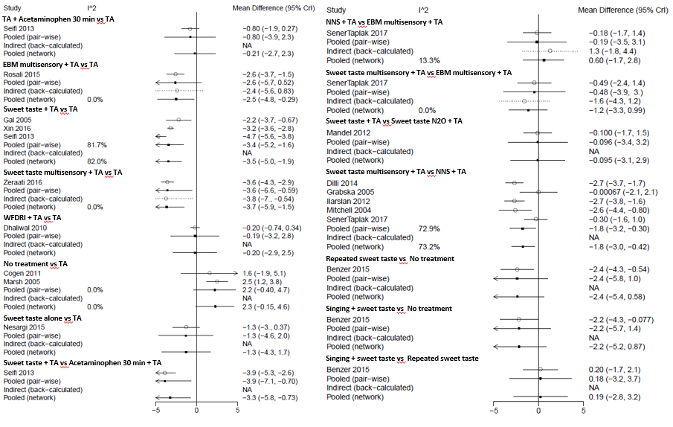

## Supplementary figure 3.5. PIPP reactivity sensitivity analysis based on SUCRA

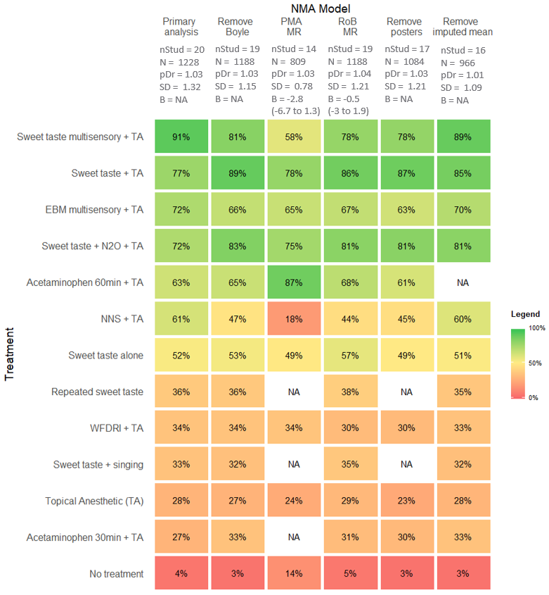

Higher scores indicating higher ranking treatment, NA indicates no information for a treatment. nStud = number of studies; N = total sample size; pDr = Ratio of residual deviance to unconstrained data points, SD = between-trial heterogeneity in units on the PIPP; MR = meta-regression. Random effect models used for all analyses.

## Supplementary figure 3.6. PIPP regulation sensitivity analyses based on SUCRA.

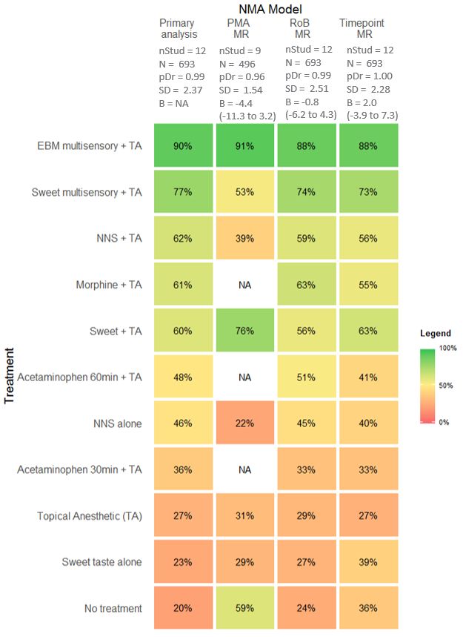

Higher scores indicating higher ranking treatment, NA indicates no information for a treatment. nStud = number of studies; N = total sample size; pDr = Ratio of residual deviance to unconstrained data points, SD = between-trial heterogeneity in units on the PIPP; MR = meta-regression. Random effect models used for all analyses.

Supplementary figure 3.7 Pain regulation league table of NMA estimates.

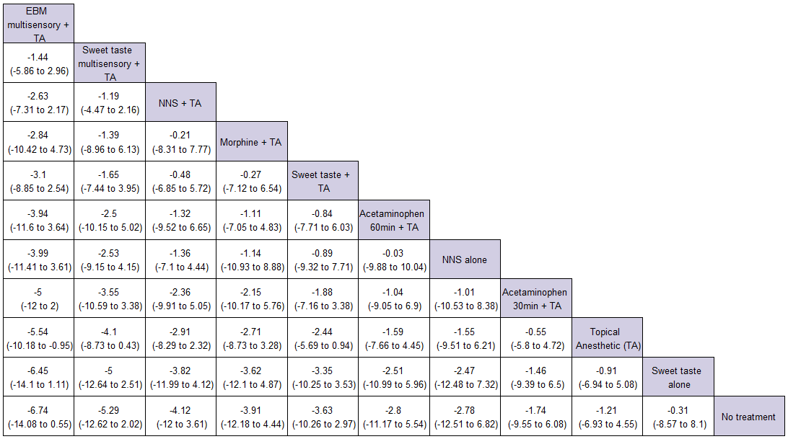

Treatments are reported in order of SUCRA ranking using a random effects model. Comparisons should be read left to right with mean differences of less than 0 indicating the treatment in the column is favoured over the treatment in the row. TA = topical anesthetic; NNS = non-nutritive sucking. Shaded cells indicate that 95% Credible Intervals exclude 0.

## Supplementary figure 3.8. Pain regulation all pairwise comparisons with direct and indirect evidence.

## Supplementary figure 3.9.Heart rate regulation league table of NMA estimates.

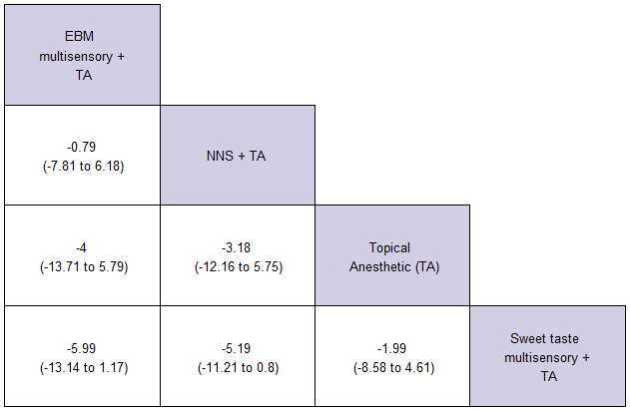

Treatments are reported in order of SUCRA ranking using a random effect model. Comparisons should be read left to right with mean differences of less than 0 indicating the treatment in the column is favoured over the treatment in the row. TA = topical anesthetic; NNS = non-nutritive sucking. Shaded cells indicate that 95% Credible Intervals exclude 0.

## Supplementary figure 3.10. SpO2 reactivity league table of NMA estimates.

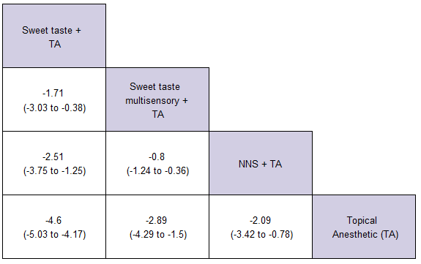

Treatments are reported in order of SUCRA ranking using a fixed effect model. Comparisons should be read left to right with mean differences of less than 0 indicating the treatment in the column is favoured over the treatment in the row. TA = topical anesthetic; NNS = non-nutritive sucking. Shaded cells indicate that 95% Credible Intervals exclude 0.

## Supplementary figure 3.11. Cry time league table of NMA estimates

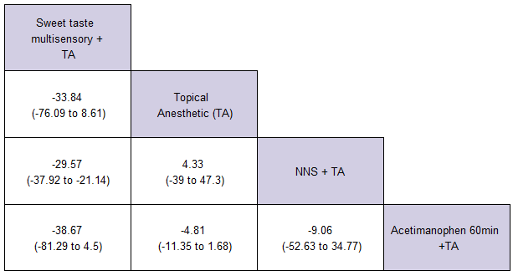

Treatments are reported in order of SUCRA ranking using a fixed effect model. Comparisons should be read left to right with mean differences of less than 0 indicating the treatment in the column is favoured over the treatment in the row. Shaded cells indicate that 95% Credible Intervals exclude 0.

## Supplementary figure 12. Adverse event reactivity league table of NMA estimates.

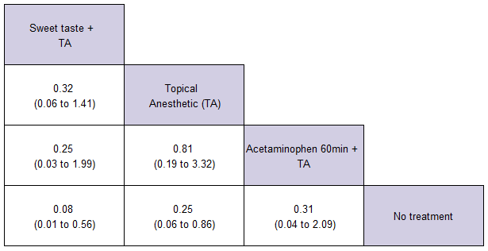

Treatments are reported in order of SUCRA ranking using a fixed effect model. Comparisons should be read left to right with odds ratios of less than 0 indicating the treatment in the column is favoured over the treatment in the row. Shaded cells indicate that 95% Credible Intervals exclude 1.

## Supplementary figure 13. Adverse event regulation league table of NMA estimates.

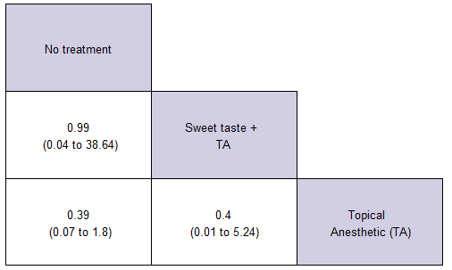

Treatments are reported in order of SUCRA ranking using a fixed effect model. Comparisons should be read left to right with odds ratios of less than 0 indicating the treatment in the column is favoured over the treatment in the row.

# Appendix 4. PROSPERO protocol and list of deviations

Pain relieving interventions for retinopathy of prematurity: a network meta-analysis

Timothy Disher, Marsha Campbell-Yeo

**Citation**

Timothy Disher, Marsha Campbell-Yeo. Pain relieving interventions for retinopathy of prematurity: a network meta-analysis. PROSPERO 2017 CRD42017058231 Available from: <http://www.crd.york.ac.uk/PROSPERO/display_record.php?ID=CRD42017058231>

**Review question**

What is the most effective intervention, or combination of interventions, for reducing pain during retinopathy of prematurity eye exams?

**Searches**

Search strategy was developed in consultation with a library professional and conducted February, 2017. Databases searched include: MEDLINE, Cochrane Central Register of Controlled Trials (CENTRAL), and Embase. As there are no consensus guidelines regarding the impact of language restriction in systematic reviews, and conflicting evidence regarding the value of reducing language restrictions, only studies published in English will be considered for inclusion. Unpublished studies will be included if provided in a format that provides the opportunity for critical appraisal. No time limits will be included.

**Types of study to be included**

Eligible studies included parallel group randomized controlled trials comparing at least two interventions intended to reduce pain from retinopathy of prematurity eye exams. Participants must be preterm neonates (e.g. <37 weeks gestational age) undergoing an ROP exam in the NICU. Trials must be published in a peer-reviewed journal or contain enough information to allow for critical appraisal.

**Condition or domain being studied**

Since the early 80s, untreated neonatal pain has been recognized as having important ethical and clinical implication. Untreated pain was most famously associated with increased mortality within the surgical environment, and as a result there have been substantial improvements in the treatment of surgical and palliative pain. Following the recognition of the importance of treating surgical pain, the potential harmful role of repeated procedural pain has also been highlighted. While these studies have been limited by the non-randomized nature of pain exposure, we have seen consistent evidence that increased exposure to procedural pain is associated with numerous short and long-term sequalae including changes in physiological stability, alterations in white and gray matter development, and internalizing and externalizing behaviours.

Retinopathy of prematurity (RoP) is a potentially serious disease that arises from the immature vasculature of the preterm retinopathy. If left untreated, RoP can result in blindness. Current guidelines recommend that infants born less than 30 weeks receive repeat serial eye exams until their retina reach maturity. Standard practice for eye exams involves indirect ophthalmic examines which require eyelid retraction and scleral indentation. This procedure is widely recognized as being painful, with neonates showing both immediate pain behaviours and prolonged physiological arousal.

In order to reduce the pain associated with RoP eye examination, researchers have identified a number of pharmacological, non-pharmacological, and procedural interventions. While this is a positive development, the plurality of approaches makes a direct comparison of all interventions unfeasible without a very large multi-centre trial. As a result, despite the topic being the subject of at least three systematic reviews, it has not been possible to provide a statistically derived estimate of the most effective treatment. The purpose of this systematic review will be to combine all existing randomized and quasi-randomized trials of pain-relieving interventions for RoP exams using network meta-analysis in order to allow for comparison of direct and indirect evidence.

**Participants/population**

Preterm neonates who require screening for retinopathy of prematurity

**Intervention(s), exposure(s)**

1. Pharmacological interventions (e.g. paracetamol, anesthetic eye drops)

2. Sweet tasting solutions (e.g. sucrose, expressed breast milk)

3. Procedural modifications (e.g. use of wide-field digital camera versus binocular ophthalmoscopy)

4. Non-pharmacological interventions (e.g. non-nutritive sucking)

**Comparator(s)/control**

Any active control, or no intervention.

**Primary outcome(s)**

Validated pain assessment scale (e.g. premature infant pain profile, neonatal infant pain scale, etc..)

**Timing and effect measures**

Pain reactivity: Measurements within one minute of the start of the procedure

Pain recovery: Measurements taken after the procedure is completed

**Secondary outcome(s)**

Behavioural measures (e.g. cry time)

Physiologic measures (e.g. heart rate, oxygen saturation)

Adverse events (e.g. bradycardia, apnea)

**Timing and effect measures**

Same as primary outcomes for behavioural and physiologic. Adverse events timing as defined by individual studies.

**Data extraction (selection and coding)**

Abstract and title screen, full-text screening, and data extraction, will be conducted independently by two reviewers using Covidence. All conflicts will be resolved by reviewers and, if necessary, consultation with a third reviewer. Data will be extracted using standardized forms.

**Risk of bias (quality) assessment**

Critical appraisal will be conducted using the Cochrane risk of bias tool for randomized controlled trials. All studies will be assessed by two reviewers. Conflicts will be solved through consensus or, if necessary, resolved by a third reviewer.

**Strategy for data synthesis**

For studies that provide binary outcome measures, we will calculate relative risks (RRs) to inform relative effectiveness. Weighted mean differences (for continuous data) and their 95% confidence intervals will be calculated for analysis.

Unit of analysis issues:

CROSS-OVER TRIALS

Cross-over trials can lead to unit of analysis issues if correlations between treatment and control are unaccounted for. If treated as if the data was generated by parallel design, the precision of the trial will be underestimated and will receive less weighting in the analysis. The Cochrane handbook outlines several methods for addressing this issue, including imputation of missing correlation coefficient. Where possible, we will request data required for an exact calculation, but otherwise impute the correlation coefficient as outlined by the handbook. Sensitivity analyses will be conducted on the values of the correlation coefficient, as well as results with cross-overs only, parallel trials only, and both combined.

Heterogeneity will be assessed visually in addition to using the standard deviation of the random effect distribution (tau). Previously established bench marks of measures of heterogeneity of the network (tau) will be used, which identify values of 0.1 to 0.49 as reasonable, 0.5-0.9 as moderate, and greater than 1 as potentially indicative of serious heterogeneity. If possible, sources of heterogeneity will be explored through subgroup analyses and/or meta-regression.

Assessment of inconsistency within the network (e.g. agreement between direct and indirect evidence) will be conducted using methods outlined by the National Institutes for Health and Care Excellence (NICE) technical support documents. Specifically, it will be assessed through the development of a consistency and inconsistency model. Point estimates of treatment comparisons will be compared between the two models, and deviation information critera (DIC) will be used as a measure of model fit. Generally, a reduction in DIC of greater than 4-5 points in the inconsistency model indicates signs on inconsistency. In addition to these methods, we will develop plots of residuals comparing the consistency and inconsistency models to facilitate identification of potentially problematic studies and/or study arms.

Relevant clinical and study design characteristics will be compared between eligible trials in order to assess acceptability for synthesis. These will include infant gestational age, birthweight, and year of publication. Pooled treatment effects will be estimated using pairwise random-effects meta-analysis with a normal likelihood and identity link for continuous data, and a binomial likelihood with logit link for dichotomous data. Results will be expressed in mean difference or relative risk as appropriate and accompanied with their 95% credible intervals. Network meta-analysis was conducted using WinBugs through the freely available NetMetaXL interface. Rankograms and surface under the cumulative ranking curve (SUCRA) will be used to estimate the probability that a given treatment would be ranked first, second, etcetera.

SKEWED DATA

Many authors report that pain scales often produce skewed data, which may have important implications for pooled analyses. We will use methods outlined by the Cochrane handbook to test data reported as mean and SD for signs of skewness. When results are reported as median and IQR, we will assess whether the assumption of symmetry was supported. In the absence of signs of skewness, we used scores as reported, treated medians and the mean and imputed the standard deviation using method outlined by the Cochrane handbook. When assumptions of symmetry were not supported by the reported results, we conducted analysis using ratio of means.

**Analysis of subgroups or subsets**

We will conduct two a priori sensitivity analyses: The first will be based on categorical specification of trials as “high risk of bias” or “low risk of bias”, and the second will investigate the potential influence of different control conditions (e.g. swaddling vs containment).

**Contact details for further information**

Mr Disher

tim.disher@dal.ca

**Organisational affiliation of the review**

Dalhousie University

**Review team members and their organisational affiliations**

Mr Timothy Disher. Dalhousie University  
Dr Marsha Campbell-Yeo. Dalhousie University

**Anticipated or actual start date**

01 February 2017

**Anticipated completion date**

30 April 2017

**Funding sources/sponsors**

Supported by student funding

**Conflicts of interest**

None known

**Language**

English

**Country**

Canada

**Stage of review**

Review_Ongoing

**Subject index terms status**

Subject indexing assigned by CRD

**Subject index terms**

Humans; Infant, Newborn; Infant, Premature; Network Meta-Analysis; Pain; Retinopathy of Prematurity

**Date of registration in PROSPERO**

27 February 2017

**Date of publication of this version**

27 February 2017

**Details of any existing review of the same topic by the same authors**

**Stage of review at time of this submission**

| **Stage** | **Started** | **Completed** |
| --- | --- | --- |
| Preliminary searches | No | Yes |
| Piloting of the study selection process | No | Yes |
| Formal screening of search results against eligibility criteria | Yes | No |
| Data extraction | No | No |
| Risk of bias (quality) assessment | No | No |
| Data analysis | No | No |

**Versions**

[27 February 2017](https://www.crd.york.ac.uk/prospero/display_record.php?RecordID=58231&VersionID=89539)

## Supplementary table 4.1. Deviations from protocol

|  |  |
| --- | --- |
| Deviation | Reason |
| Pain regulation moved to secondary outcomes | In the process of conducting the review it became apparent that clinical decision making was most-influenced by findings from the immediate pain reactivity phase |
| Node-splitting model used in favor of inconsistency model to assess inconsistency | The software used provides more robust support for the use of node splitting models. |
| No meta-regression on swaddling/containment and extra meta-regressions on post-menstrual age and actual time point | Exploratory analysis showed no association between whether infants were swaddled vs contained during the procedure, and as the mechanism of action for analgesia are similar they were not formally assessed through meta-regression. Post-menstrual age and actual time point measured in regulation phase (e.g. 1 minute vs 2 minute post) appeared to show evidence of a linear trend with treatment effect. |